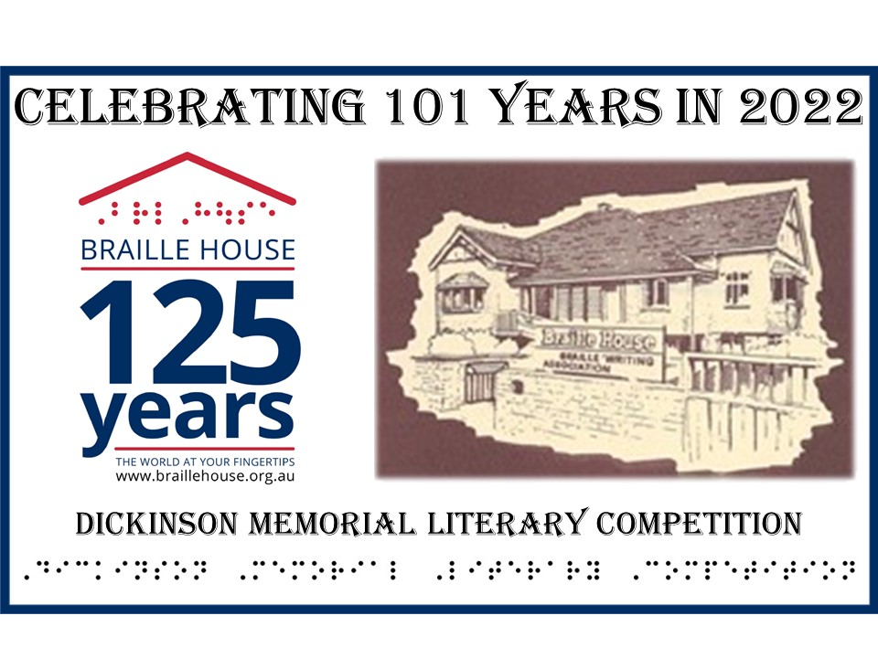

Braille House is proud to announce that the Dickinson Memorial Literary Competition for 2022 is now open for entries from all Australian residents and the theme for our 101st year is TIME.

Spread the word about this opportunity to pen a short story or poem and be in the running to win cash prizes in the 101st year of the Dickinson Memorial Literary Competition which is a National literary competition and is for children and adults who are blind or have low vision.
To enter, please go to https://www.braillehouse.org.au/dickinson-2022/

People who are blind or have low vision have told their stories for 101 years through this unique competition.
This year is your turn!

The Dickinson Memorial Literary Competition is a national competition and is for children and adults who are blind or have low vision. There is also special “People’s Choice” award that will be open to anyone (even if you are sighted) and all entries in this category will be published on the Braille House website and the audience will get to choose the winner.

Entry is only $10 per category and there are 6 categories for all ages to enter and prize money is awarded in every category: $350 first prize per category and $150 second prize per category (judge’s decision is final).

Prizes awarded in 6 Categories:
- Adult Short Story
- Adult Poem/Song Lyrics/Limerick
- Adult Article/Opinion e.g.: self-reflection, blog
- Senior Student Creative Category, e.g: story, poem, song lyrics, limerick, blog,
- Junior Student Creative Category, e.g: story, poem, song lyrics, limerick, blog
- People’s Choice Category – Short Story. (All People’s Choice” entries will be published online for the public to vote).
Manuscripts must be an unpublished work, not on offer for publication before the announcement of awards and not have been recognised in any other competition.
Entries close Friday September 16 at 4pm. Entries should be submitted in hard copy Braille, Simbraille or Duxbury-readable file or in a Word document

Timing of competition: Entries close Friday September 16 at 4pm. Winners announced Friday October 7th at 4pm and then we publish the winners and runners up in a special anthology.

This unique competition has a proud history of showcasing the work of blind and low vision writers to a broader audience and has provided a platform for these people to tell their amazing stories.

Dickinson Memorial Literary Competition History:

History: The competition was started in 1921 by the “Queensland Musical, Literary and Self Aid Society for the Blind as an Essay Competition; the subject was “Self-Reliance” and first prize in each category was One Guinea.

Both Harold Dickinson and his brother Edwin were members of the QMLSAS and were very involved in the literary and musical world at that time although Harold averred that it was Edwin who was the literary brother. Edwin died in January 1956 but his name continued to be synonymous with the competition.

The Society changed its name in 1966 to Queensland Society of Blind Citizens and in 1986 it acquired royal assent to use the prefix Royal. Then it all became complicated! In 1988, the name of the organisation was shortened to Royal Blind Society of Queensland. In the decade that followed, a number of amalgamations occurred of organisations serving the VI community. The QBIC (Queensland Blind Industrial Centre) had become part of the QFBP (Queensland Foundation for Blind People) (previously Queensland Training and Placement Centre for the Blind in which the Dickinsons – Harold and Mercy – were founders together with Malcolm Bryce and Eric Searle). The QBIC component separated and became Vision Queensland. The QFBP became the Royal Blind Foundation of Queensland and continued so until 2006 when it and Vision Queensland became part of Vision Australia. The competition found its way home to Braille House and we are proud to be continuing this important competition for the 101st year in 2022.

We welcome participants in the 101st Anniversary of The Dickinson Memorial Literary Competition and wish you all good luck and a happy writing experience.

For any questions, please contact me on the details below

Andrew Backhouse
Marketing, PR and Community Engagement
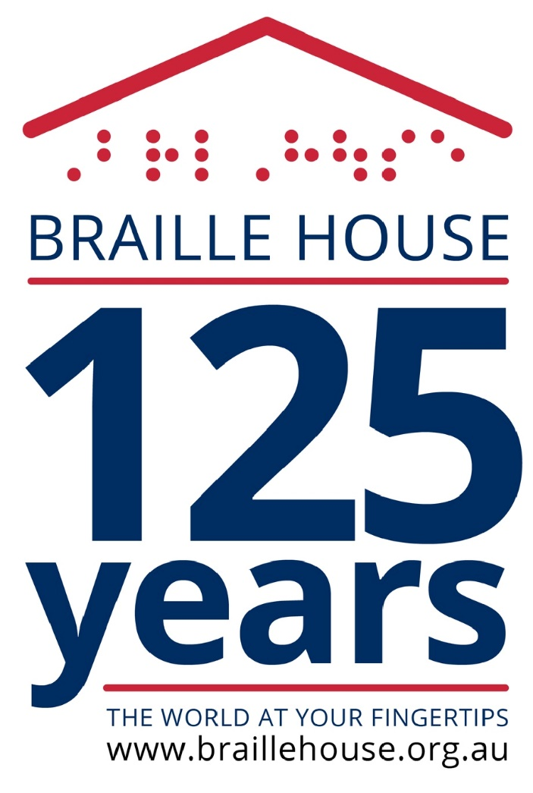
P: (07) 3848 5257
M: 0409 878 791
E: AndrewBackhouse@qbwa.org.au
W: www.braillehouse.org.au

